The Philippines is a republic with a Presidential form of government, with powers divided between three branches: Legislative, Judiciary, and Executive.
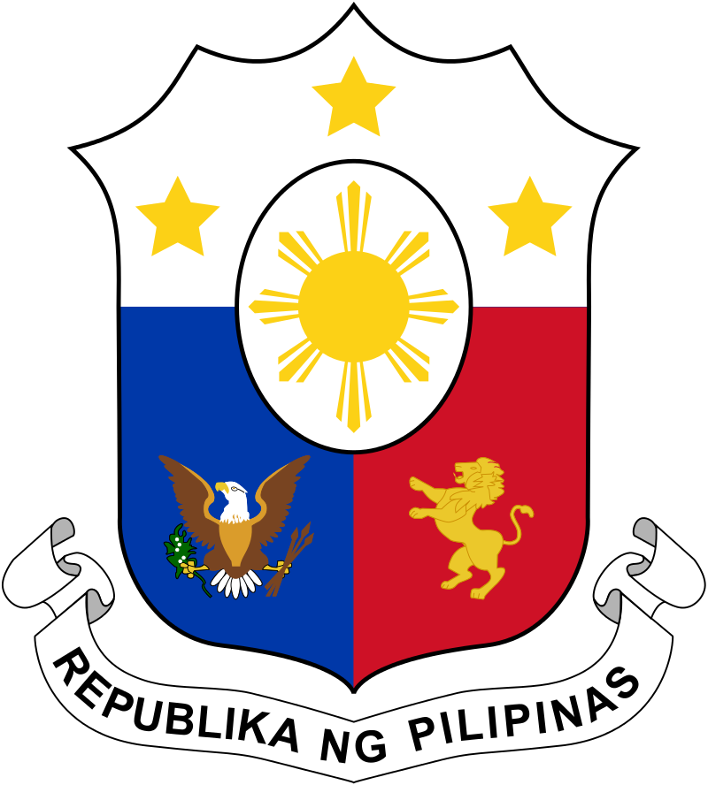
The Current Vice- President of the Philippines, Jejomar Binay, elected in 2010.
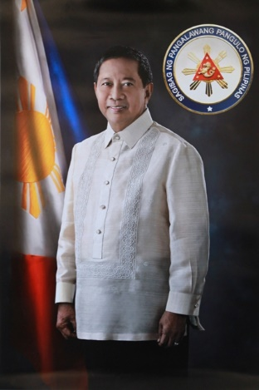
The current President of the Philippines, Benigno Aquino III, elected in 2010.
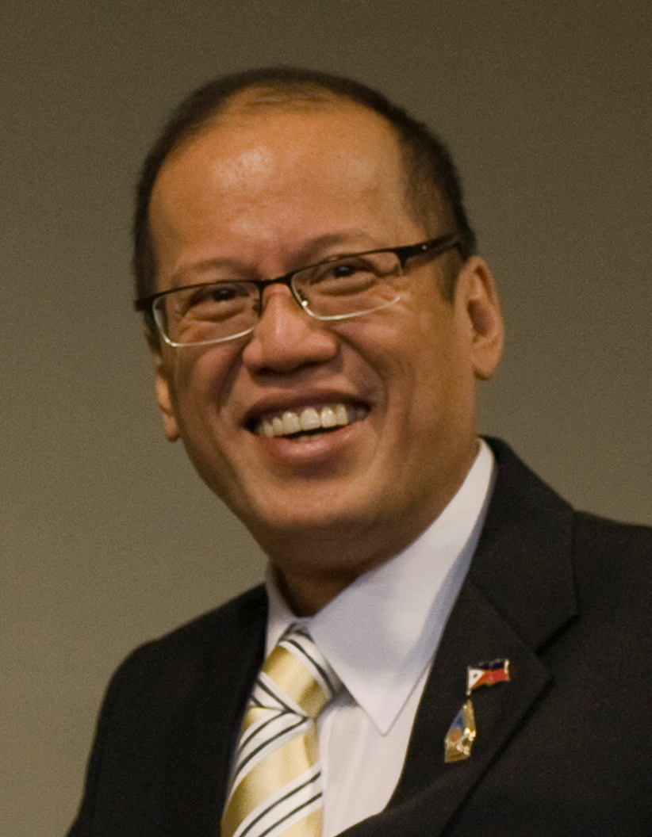T
Executive
The executive branch consists of the President, Vice President and the Cabinet. The president and Vice President are elected by popular vote every 6 years. The current President is Benigno Aquino III and the current Vice President is Jejomar Binay. They were elected in the 2010 election.
Judiciary

All Judiciary Power in the Philippines is vested in the Supreme Court. The philippine supreme court consists of a chief justice and 14 associate Justices. Each justice serves until age 70 and are appointed by the president. The Judical branch settles controverises involving constitutional rights. The current chief justice is Maria Lourdes Sereno.
Office of Ombudsman
The Office of Ombudsman was established to monitor each of the three branches of government. The ombudsman can investigate and prosucuete any government offically who is allegdly guilty of a crime. The office has 6 deputies: overall, Luzon, visayas, armed forces, mindanano, and special prosecutor.
Legislative
The power to make, alter and repeal laws is vested in the Philippine Congress. The Philippine congress is separated into 2 houses: The House of Representatives and the senate. The president of the Senate is Franklin Dillon and the Speaker of the house is Feliciano Belmonte, Jr.
House of Representatives:
- Lower house is located in Quezon City
- Upper House is located in Pasay
- Representatives are elected every 3 years and may not run for more than 4 terms.
Senate:
- Senators are elected every 6 years and may not run for more 3 terms
Government of the Philippines

